**Homework # 8**

**01286121 Computer Programming**

**Software Engineering Program,**

**Department of Computer Engineering,**

**School of Engineering, KMITL**

By

65011693 Soe Moe Htet

No.1

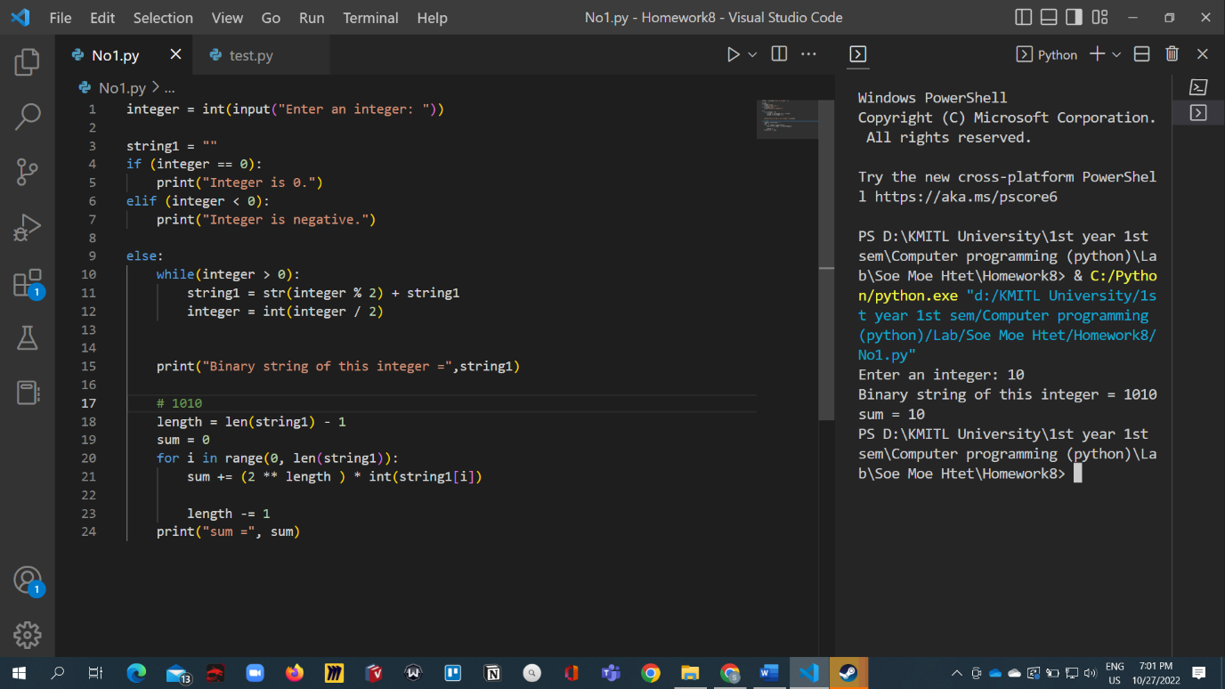

No.2

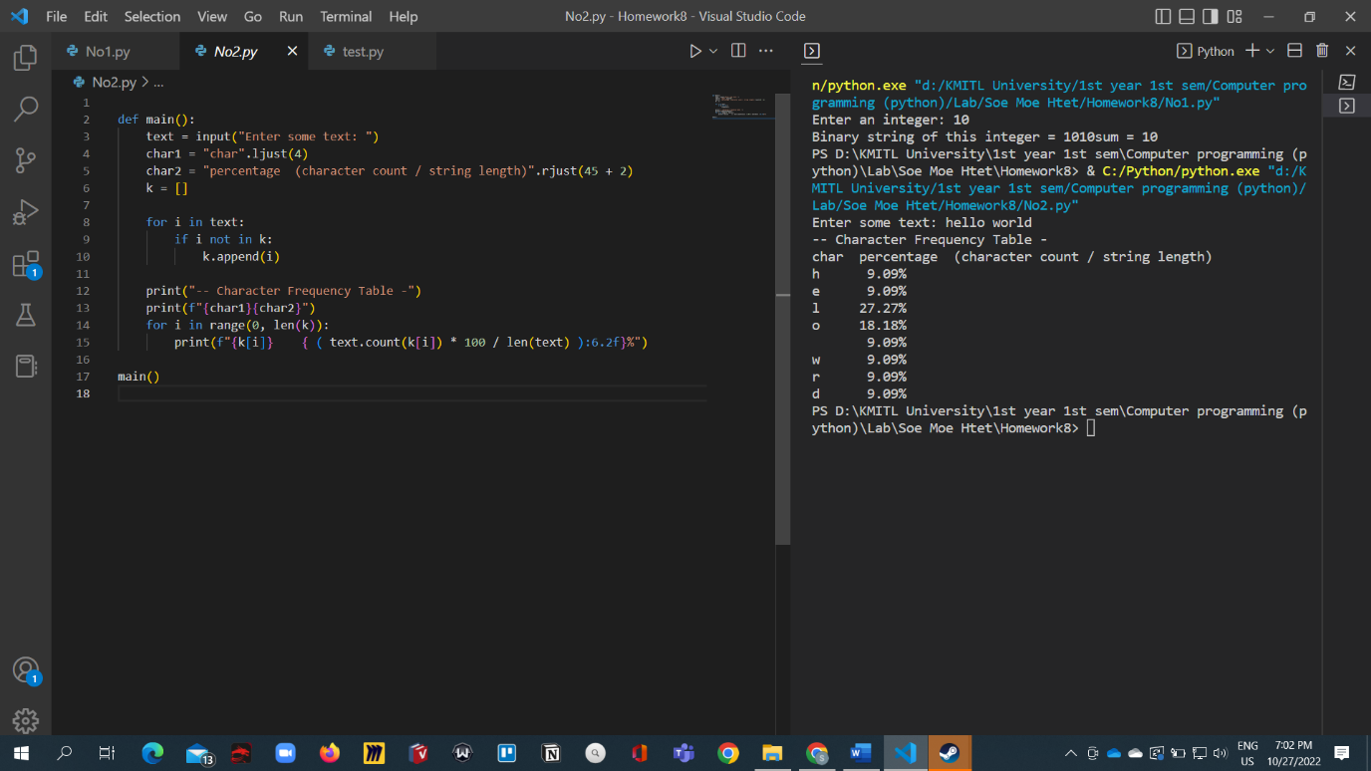

No.3

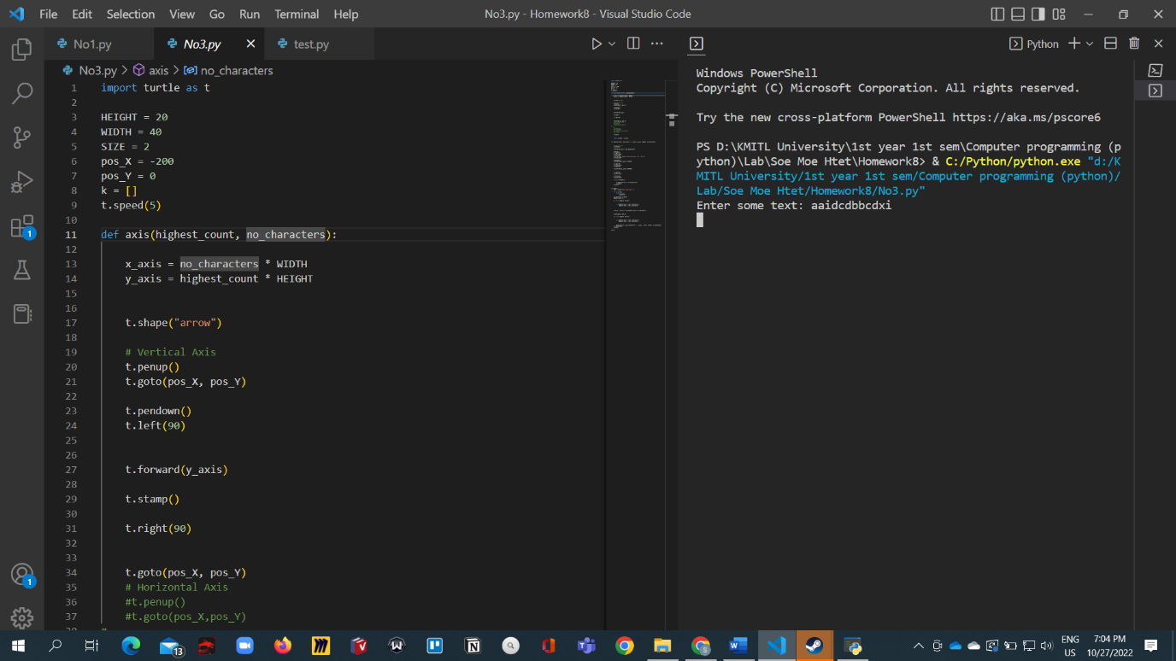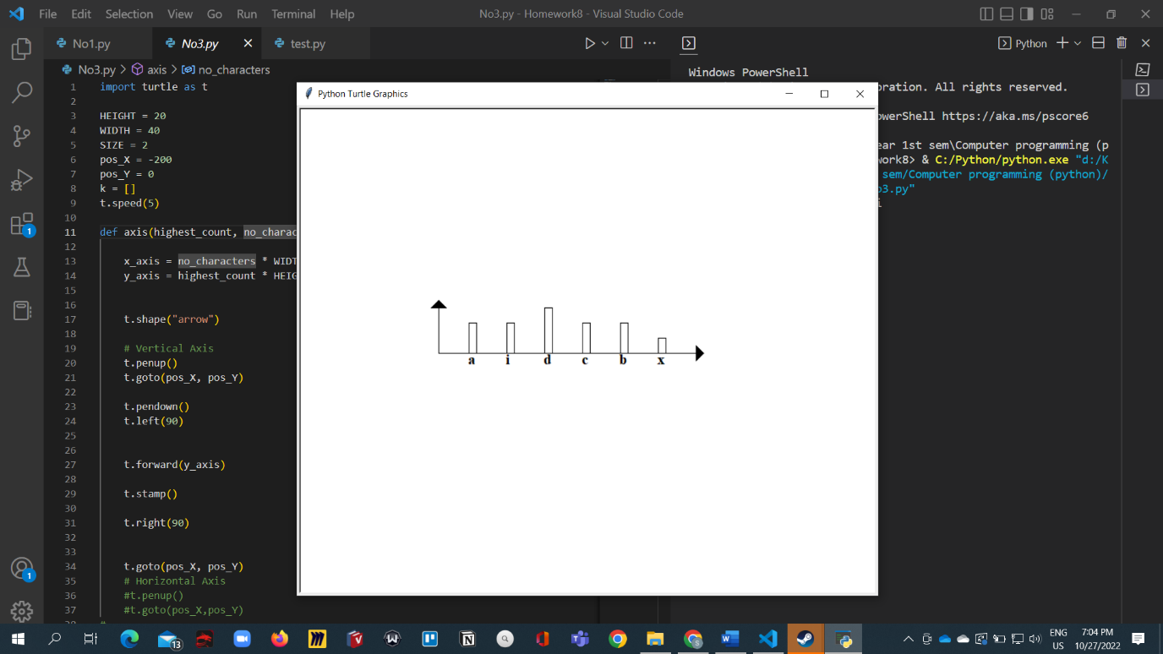

Code

import turtle as t

HEIGHT = 20

WIDTH = 40

SIZE = 2

pos_X = -200

pos_Y = 0

k = []

t.speed(5)

def axis(highest_count, no_characters):

    x_axis = no_characters * WIDTH

    y_axis = highest_count * HEIGHT

    t.shape("arrow")

    # Vertical Axis

    t.penup()

    t.goto(pos_X, pos_Y)

    t.pendown()

    t.left(90)

    t.forward(y_axis)

    t.stamp()

    t.right(90)

    t.goto(pos_X, pos_Y)

    # Horizontal Axis

    #t.penup()

    #t.goto(pos_X,pos_Y)

#

    #

    #t.pendown()

    #t.right(90)

    #t.forward(x_axis*SIZE)

    #t.stamp()

    t.penup()

    return (x_axis , y_axis)

def draw_bar(char, text_count, i, x_axis, y_axis, length, no_characters):

    # Character bar

    t.pendown()

    t.forward(x_axis / (no_characters))

    t.penup()

    t.right(90)

    t.forward(20)

    t.left(180)

    t.write(char, font=("Times New Roman", 15, "bold"))

    t.forward(20)

    t.pendown()

    t.forward(text_count * HEIGHT)

    t.right(90)

    t.forward(10)

    t.right(90)

    t.forward(text_count * HEIGHT)

    t.right(90)

    t.forward(10)

    t.left(180)

    t.forward(10)

    if (i == length-1):

        t.forward(x_axis / (no_characters))

        t.stamp()

    t.penup()

def main():

    text = input("Enter some text: ")

    for i in text:

        if i not in k:

            k.append(i)

    no_characters = len(k)

    highest_count = 0

    for i in range(0, len(k)):

        if (highest_count < text.count(k[i])):

            highest_count = text.count(k[i])

    (x_axis, y_axis) = axis(highest_count, no_characters)

    t.goto(pos_X, pos_Y)

    for i in range(0, len(k)):

        if (highest_count < text.count(k[i])):

            highest_count = text.count(k[i])

        draw_bar(k[i], text.count(k[i]), i, x_axis, y_axis, len(k), no_characters)

    t.hideturtle()

    t.done()

main()

No.4